**PASS AUTOMATION & ACCOUNTAL SYSTEM**

System Prerequisites:

1. System with Internet Connection of moderate speed.
2. Browser, preferably Mozilla firefox, Google chrome.
3. Enter url : apsrtcpass.in in browser’s address bar.
4. Check the status of Java script in browser, if disabled please enable Java Script.

(If any warning message populates on the screen above the Bus Bhavan image it means java script is disabled in your browser, if not everything is fine.)

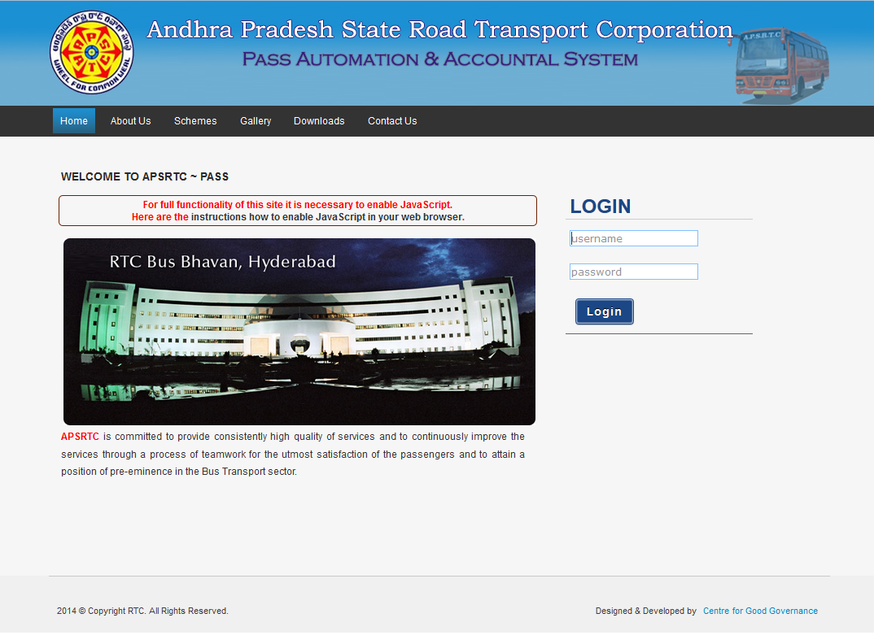

1. Enabling Java script in Mozilla firefox.
   1. In the address bar, type **about:config**, and press **Enter**.
   2. Click **I’ll be careful, I promise**.
   3. In the search bar, search for **javascript.enabled**.
   4. Right-click the result named **javascript.enabled**, and click **Toggle**. JavaScript is now disabled as the value is set to **true**.
2. Remove Header & Footers in browsers page setup. Set all headers & footers to –blank--

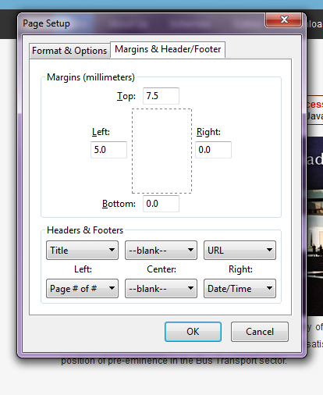

1. Disable printing of background data. Uncheck the options => Print Background

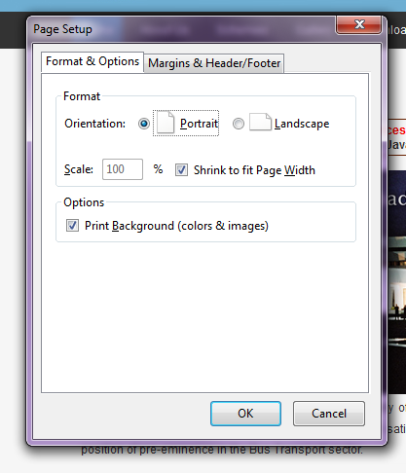

1. Adjust Margins in browsers page setup for printing.



1. Default Margins for Ticket
   1. top : 7
   2. Left : 5